Quimby, C. (n.d.). Retrieved from: http://mrsquimbyreads.blogspot.com/

Text Features | Image | Purpose
Titles | 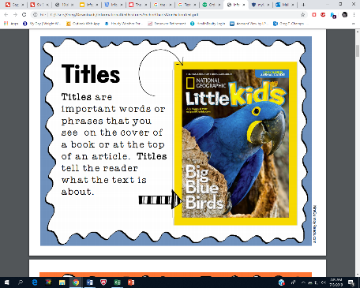 | Important words or phrases that you see on the cover of a book or at the top of an article. Titles tell the reader what the text is about.
Headings  and  Subheadings | 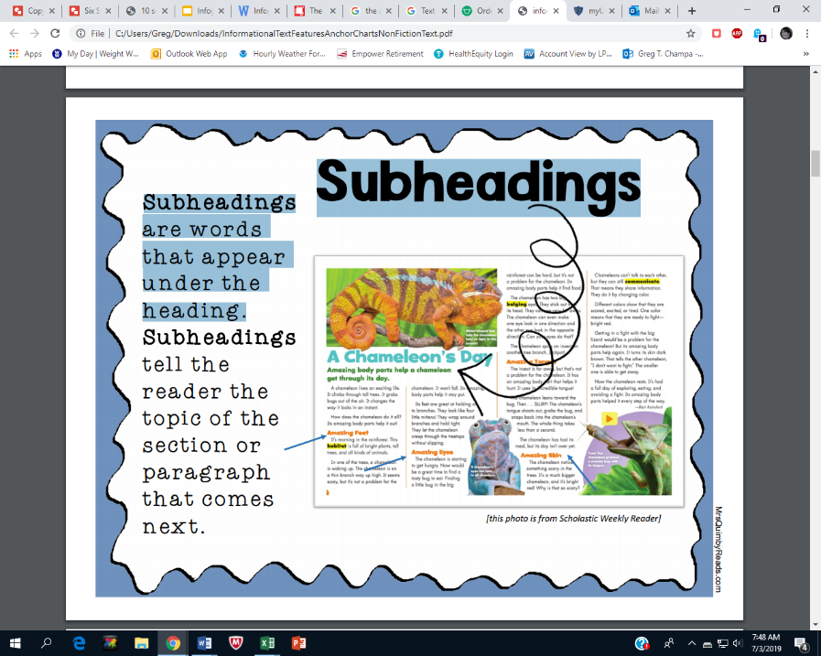 | Headings are words or phrases at the beginning of a new section or chapter. Subheadings are words that appear under the heading. Both clue the reader of the upcoming topic.
Icons | 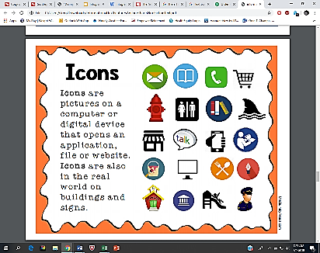 | Pictures on a computer or digital device that opens an application, file or website. They are also in the real world on buildings and signs.
Time Lines | 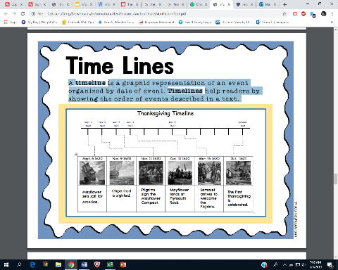 | A graphic representation of an event organized by date of event. Timelines help readers by showing the order of events described in a text.
Graphs | 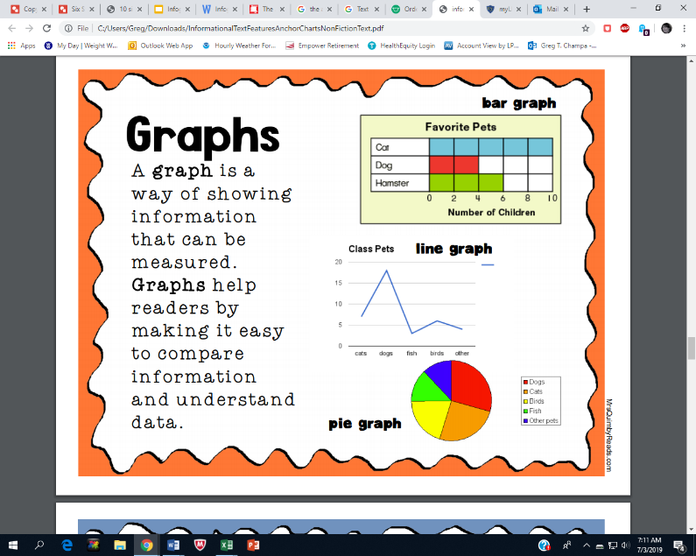  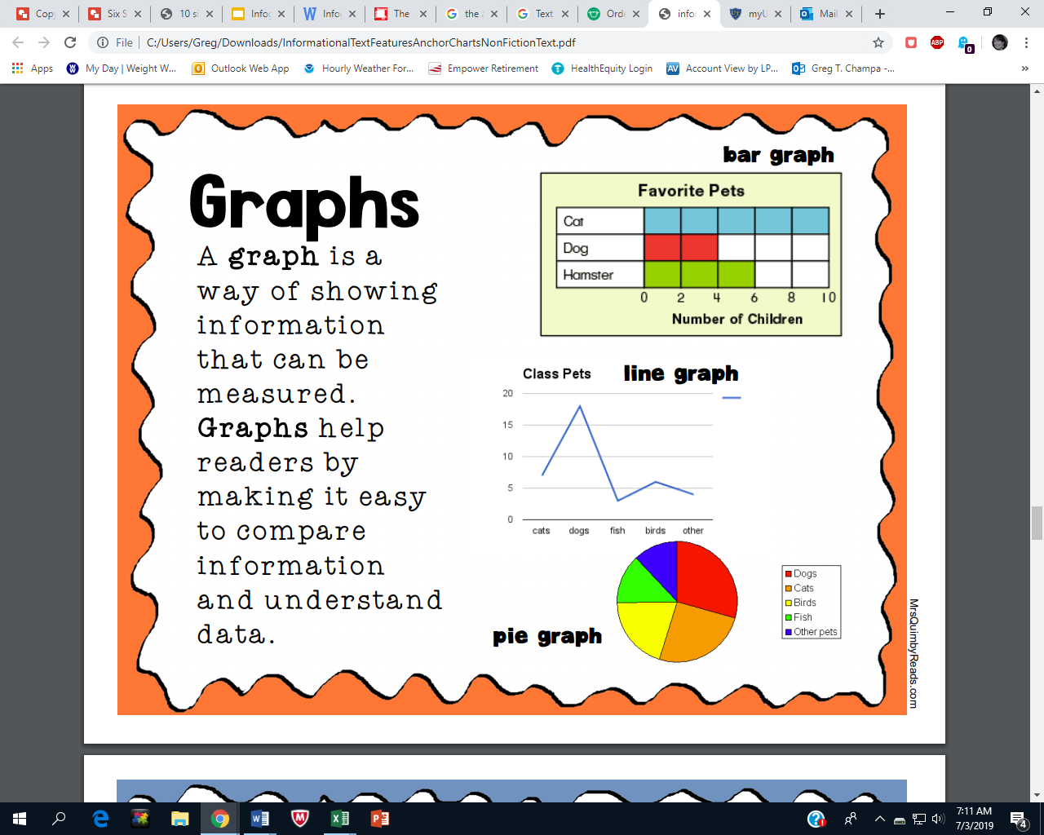  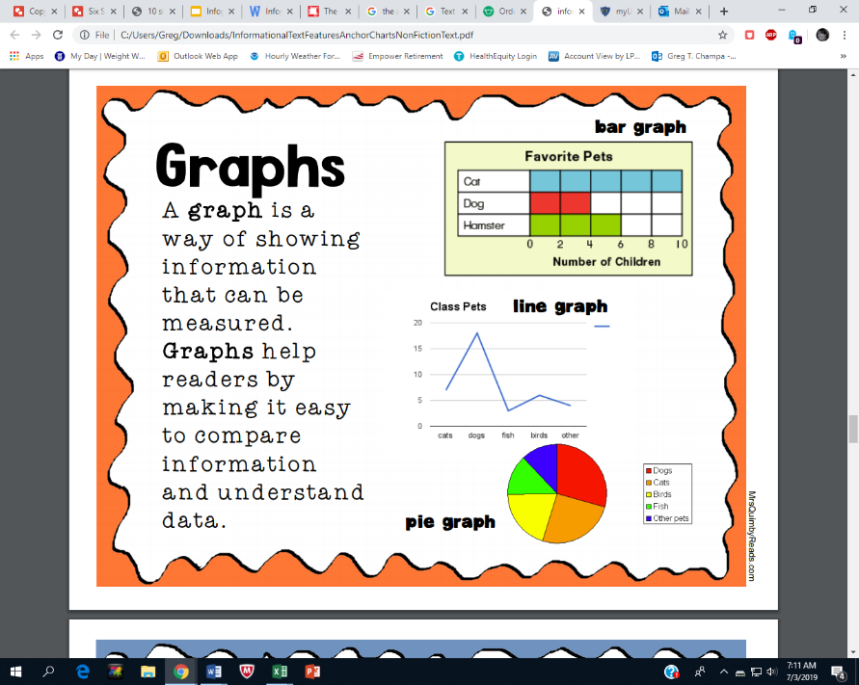 | A way of showing information that can be measured. Graphs help readers by making it easy to compare information and understand data.
Maps | 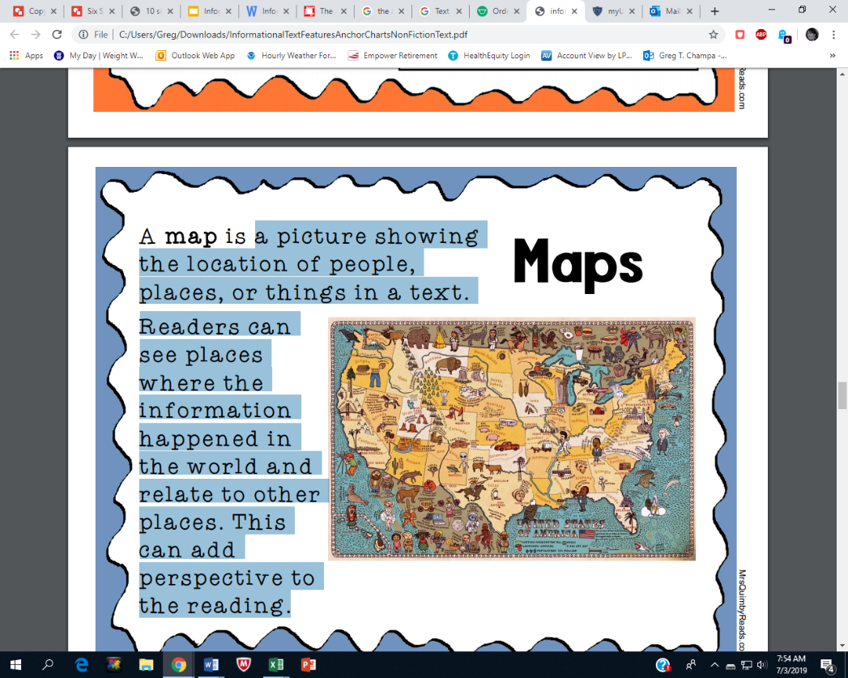 | A picture showing the location of people, places, or things in a text. Readers can see places where the information happened in the world and relate to other places. This can add perspective to the reading.
Photographs Illustrations  Diagrams | 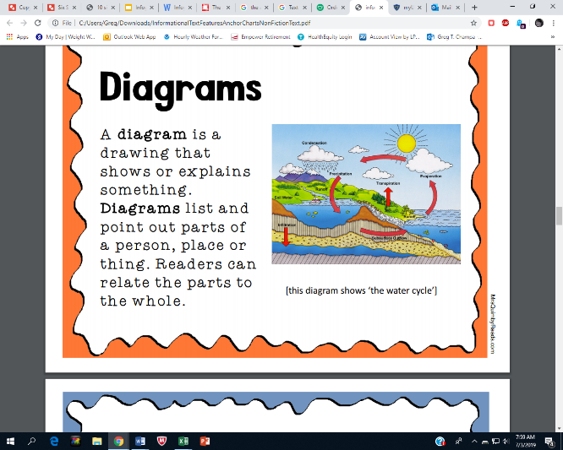  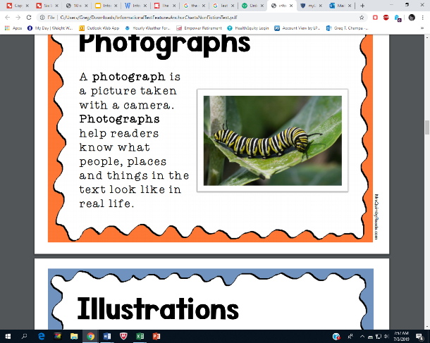  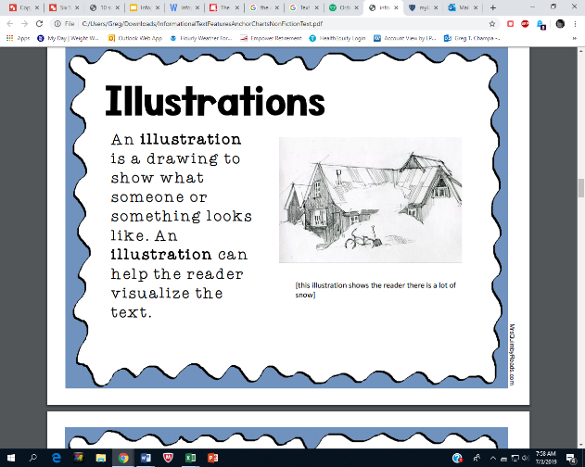 | Visuals used to enhance the reader’s understanding of the text. Photographs depict real life. Illustrations show what something may look like. Diagrams list and point out parts of a person, place, or thing. Readers can relate the parts to the whole.

